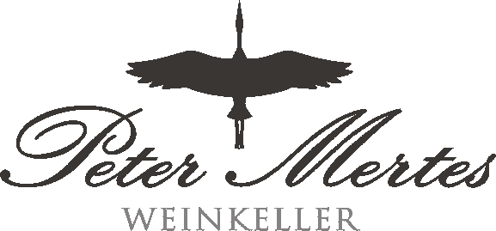

Manufacturing Process

Arrival of the wine at PM
According organic regulations
(for foreign wines EU-law applies)
↓
Sensoric evaluation and
full analysis at our wine laboratory
with full documentation
↓
Unloading into our stainless steel tanks
↓
Filtration
↓
Blending
↓
Final Filtration,
blend-analysis, sensoric evaluation
with full documentation
↓
Bottling on a fully automatic bottling line
- with add. membrane filtration before filling
- with cork closures and labelling
- with check on filling level by light stream
↓
Packing / Delivery

