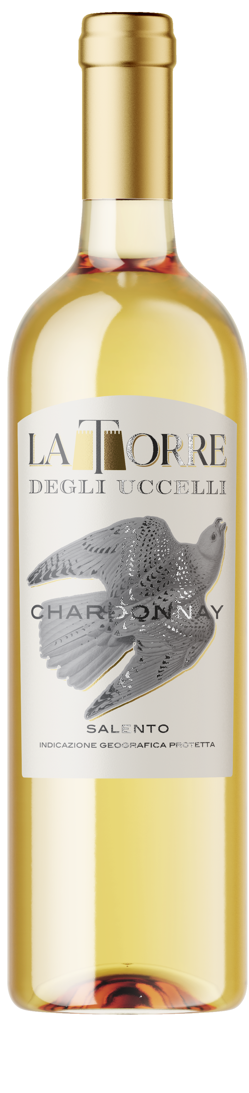
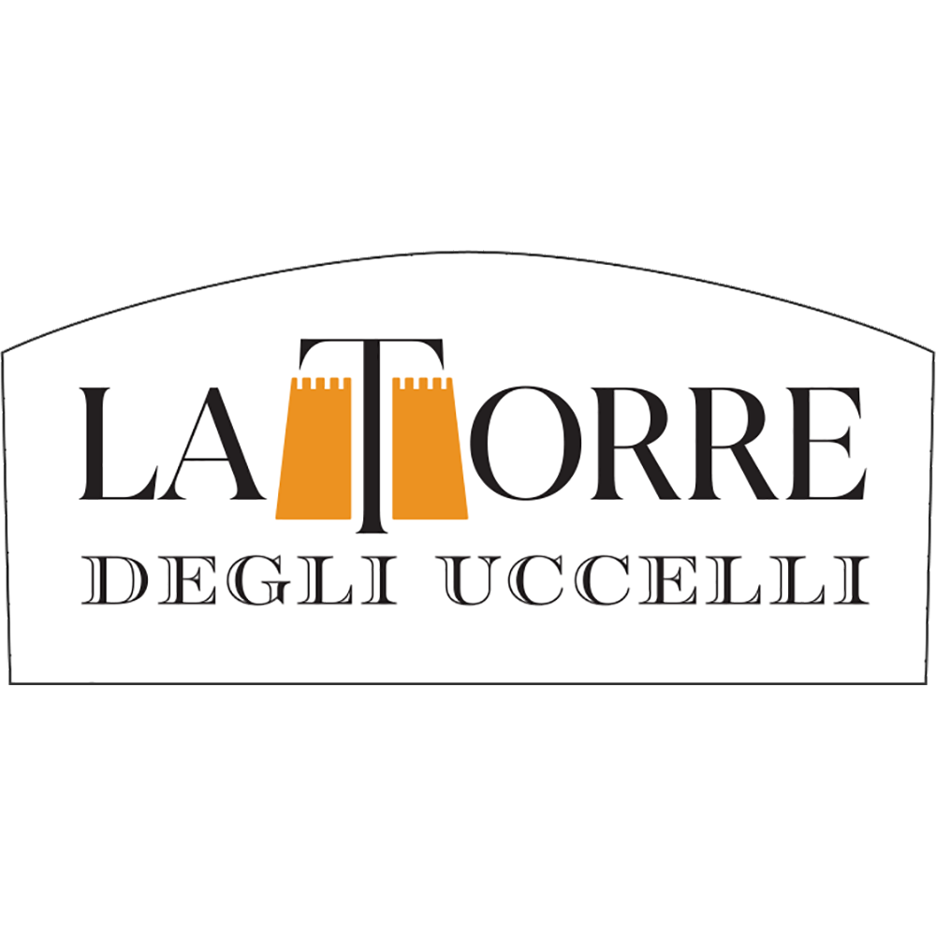
LA TORRE CHARDONNAY, SALENTO IGP

Wine obtained from selected Chardonnay grape, harvested in the second half of August.
The must is separated from skins and after a 12-hour contact with them at 4°C temperature; it is placed into stainless steel vats where alcoholic fermentation takes place at 15°C.

Straw coloured with full-bodied vanilla and ripe fruit smells. It is fresh, lively and well balanced to the palate. It is structured, harmonious and persistent; its flavour is dry and delicate.

12%vol
750ml
Grape:
100% Chardonnay
Food pairing:
Fish dishes, row meat and white meats.

