

LA TORRE , ROSATO SALENTO IGP
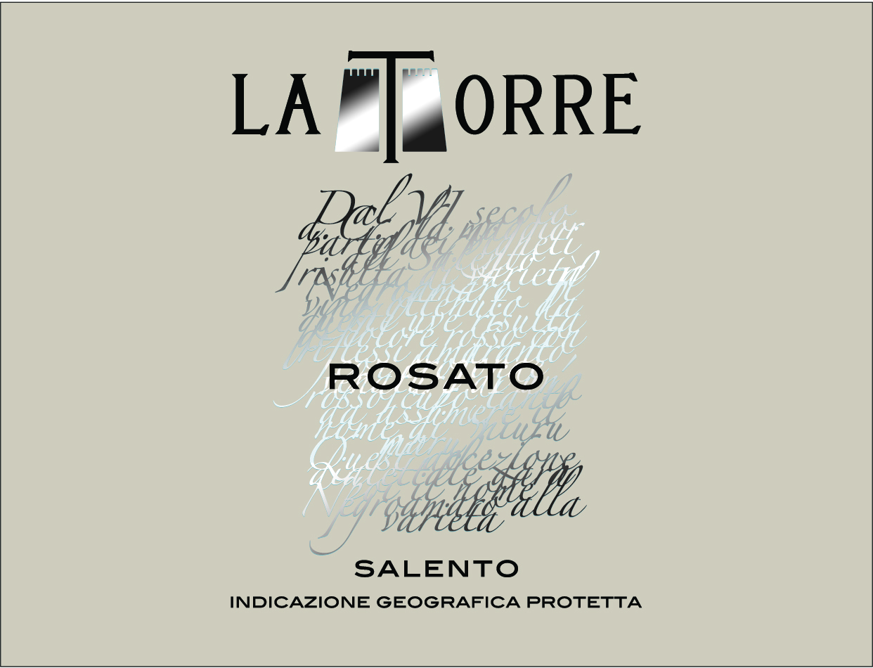
Rosé Salento IGP
Wine obtained from selected Negroamaro and Malvasia Nera grapes, harvested in the first days of September.
The color is the result of a slight contact between skins and must (just 6/7 hours). The alcoholic fermentation at a temperature of 15°C and the refining into thermo regulated steel tanks enhance the aromas and the smells of this rosé.

Excellent rosé with an intense pink colour, a nice bouquet scent and a fresh aroma of tropical fruits

12.5%vol
750ml

Grape:
80% Negroamaro,
20% Malvasia Nera

Food pairing:
First courses, fish soups and second courses of white meat

