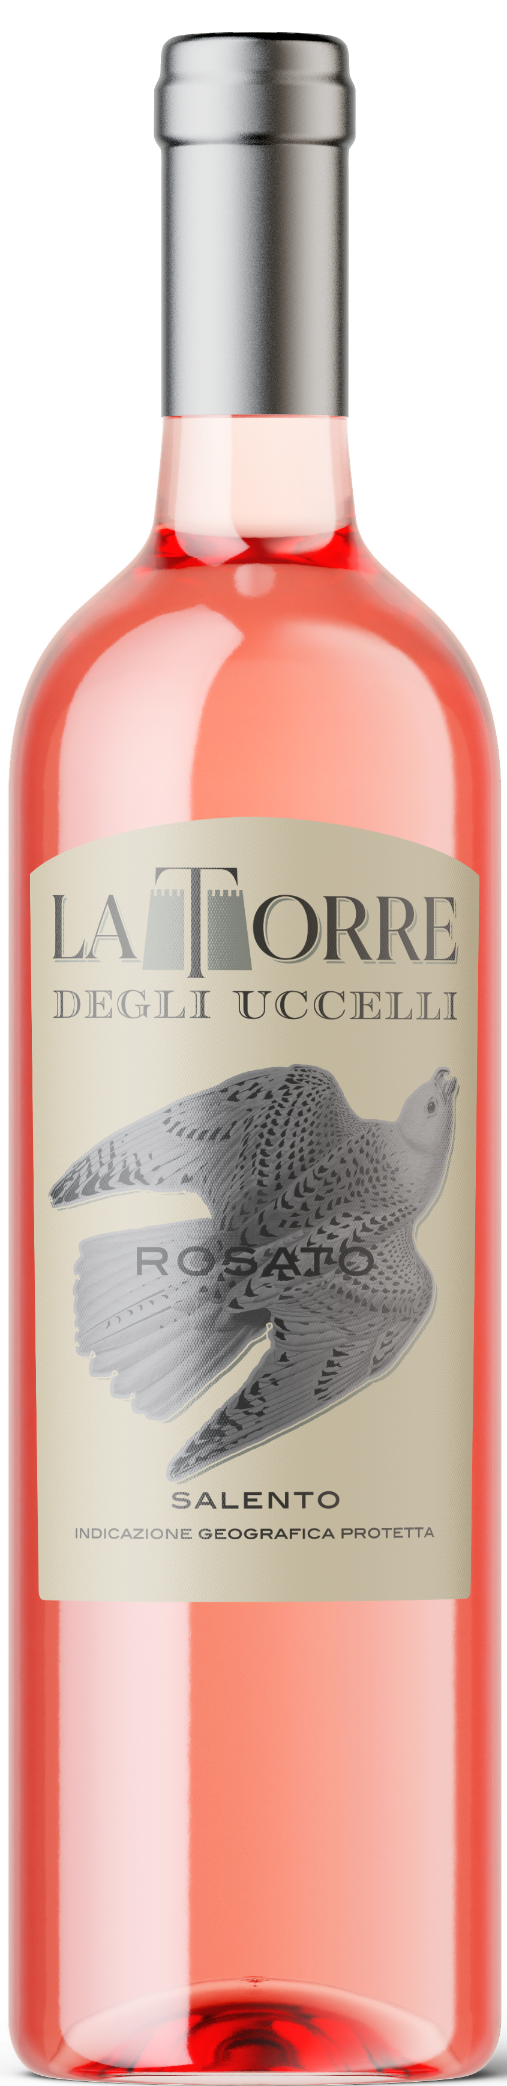
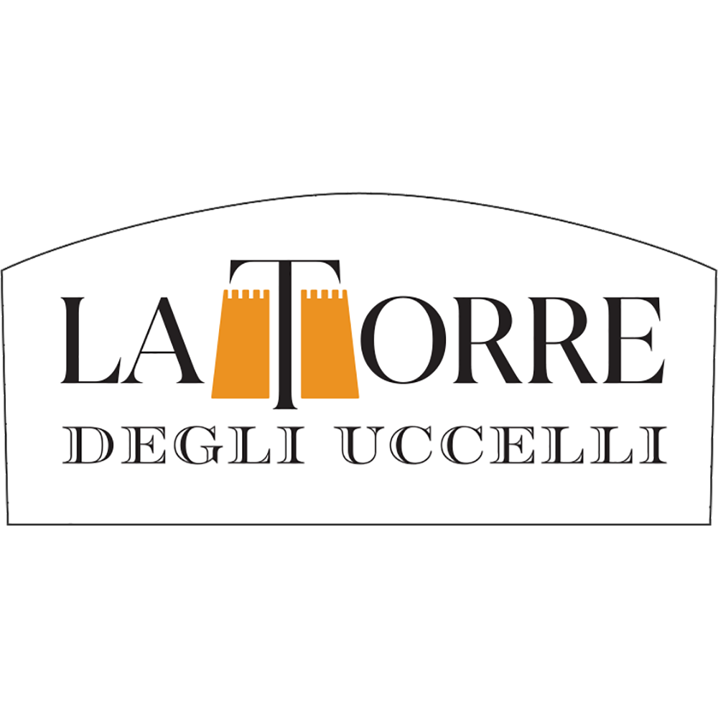
LA TORRE , ROSATO SALENTO IGP
Wine obtained from selected Negroamaro and Malvasia Nera grapes, harvested in the morning in the first days of September.
The color is the result of a slight contact between skins and must (just 6/7 hours). The alcoholic fermentation at a temperature of 15°C and the refining into thermo regulated steel tanks enhance the aromas and the smells of this rosé.
Excellent rosé with a light pink colour, a nice bouquet scent and a fresh aroma of tropical fruits and red little fruits

12.5%vol
750ml
Grape:
80% Negroamaro,
20% Malvasia Nera
Food pairing:
First courses, salads, fish soups, grilled fish and white meats…Try it in aperitive!

