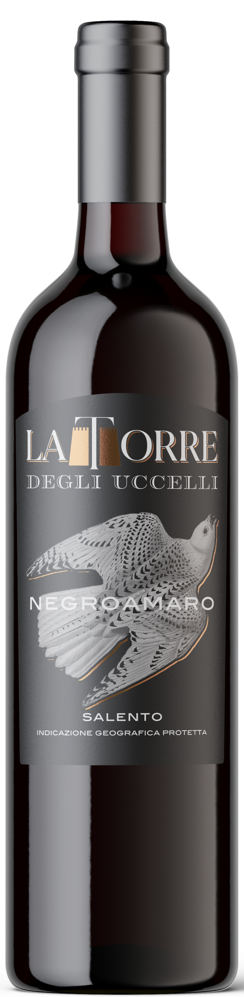
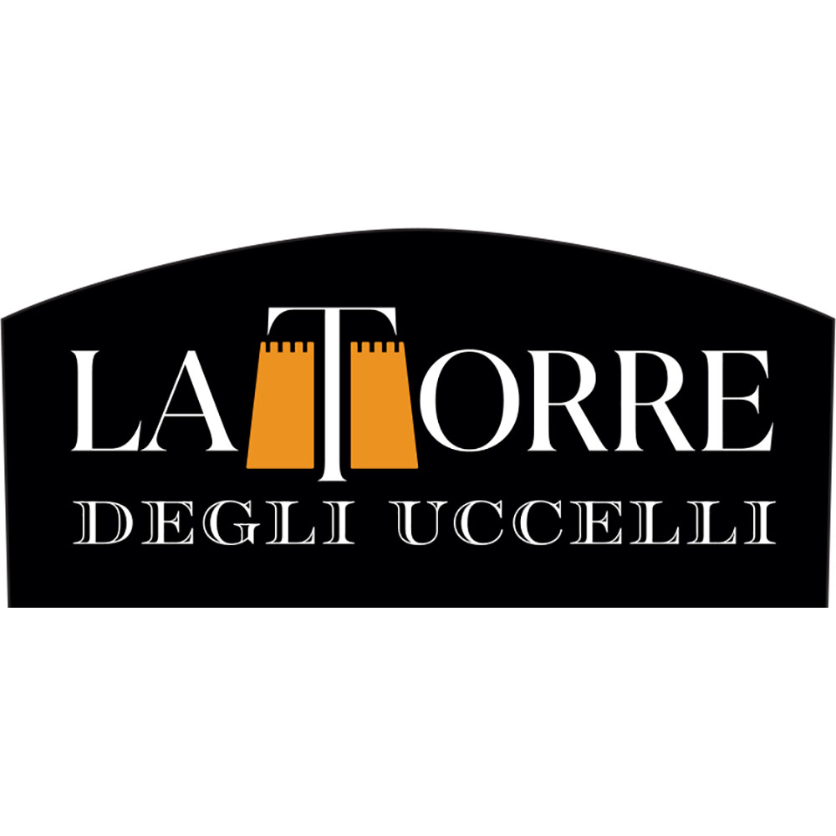 LA TORRE NEGROAMARO SALENTO IGP
This wine is obtained from selected Negroamaro grape, harvested in the first weeks of September.
The maceration takes place into horizontal rotating stainless steel vats, where the wine completes its alcoholic fermentation.
The intense ruby red colour is the result of controlled grape skins fermentation in horizontal rotary vats. It has an intense scent and slightly dry tannic taste.
12.5%vol
750ml
Grape:
100% Negroamaro

Food pairing:
Meat sauce pasta dishes, grilled meat, stewed poultry and game

