
Bodegas Paniza D.O.P Cariñena, Spain

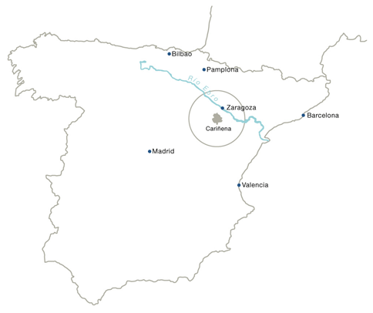

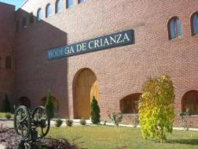

History

Wine has been made in the Cariñena region since Roman times (over 2000 years ago). The town of Cariñena itself used to be called Carae, which was a Roman farm estate, with vineyards and olive groves. In those days, wine was consumed locally and taken to the Roman town of Zaragoza, 60 km to the north, whose name derives from Caesar Augusta, the Roman emperor.

In the middle ages, wine continued to be made principally for own consumption and for sale in the region of Aragón, but also further afield in Madrid and Valencia.

The region became an important source of young bulk wine to Bordeaux, when phyloxera wiped out French vineyards (which occurred several years before those of Cariñena were affected).

Up until the mid 1900s, the region continued being an important source of wines for wineries in France and Rioja, through which Cariñena’s native grape varieties- Cariñena (Carignan), Garnacha (Grenache) and Viura became known abroad.

In 1932, Rioja was the first region to gain DO status in Spain. In 1933, Cariñena was the second.

Since DO status, and mainly in the mid 1900s, many farmers in the region began to form cooperatives, based around their own villages, in order to better secure the sale of their wines- bottled and branded and showing the Denomination of Origin Cariñena.

Bodegas Virgen del Águila was formed as such in 1953 in the village of Paniza, being named after the Virgin of the Eagle shrine in the mountains above the village.

With a huge investment in the modernization of the facilities (barrique room, high technology steel tanks and bottling line), there was a important step towards improving the quality of the wines. It was the acquisition of the multi-analyzer. Previously, the viticultors were paid according to the grade and total kgs of the grapes that they came into the winery. The new system was implanted in 2012 and it consisted of the payment based on some parameters: variety, sanity, acidity, ph, colour, sugar, age of the vines between others. This way, the quality was more important than the quantity. The viticultors had an incentive to take care of the more demanding grape varieties (according to the demand of the market) and the old vines (low yield but high quality).

Nowadays, the winery is named after the town of Paniza and it has 425 farmers, all from Paniza (whose economy is highly dependant on wine) and who sell their grapes exclusively to their winery, through contracts based on grape variety, age of vines, location and a set of rigorously controlled grape quality criteria. For the farmers, the financial and personal incentive is strong to produce the best possible quality grapes, maintain old vines, farm the best lands for wine, and to use the best forms of viticulture.

The winery has an in-house viticulturalist and 2 wine-makers: Joaquín Pérez (over 25 years working at the winery) and Antonio Serrano (Spanish with experience in USA, Australia…) , who advise farmers of the best practices, controls quality measures in the vineyards throughout the year, and individually selects grapes from different vineyard parcels for the creation of specific wines (such as Agostón Garnacha, made from hand-picked old vine grapes, which have low yields and an intense concentration of aroma and colour, or the Agostón Viura-Chardonnay white wine from the slate mountains at 850 metres elevation, which have a cool micro-climate ideal for this wine).

The sum total of the vineyard area belonging to the farmers is 2.500 hectares, with all its vines being located in the area immediately surrounding the winery and the village of Paniza, at the base of the Ibérico mountains, an area of outstanding natural beauty and environmental importance, which is safe-guarded by a large total area of protected natural zones and by careful cultivation practices.

The winery in turn buys its grapes exclusively from its own farmers, producing a volume of around 15 million kg per year, sufficient volume-wise for the creation of strong brands and a good range of wines across different markets.

Traditionally, the cooperative had two large markets- Germany and Spain, and has been certified to IFS and BRC standards since the early 1990s.

Since 2007, the winery has set out on a new strategy of market expansion (with a focus on northern Europe, North America and the Far East), brand creation, development of tailor-made wine styles and the commercialisation of wines with an excellent price to quality ratio and suitability to the market (with a mission of giving consumers the best possible value for money). Since this year, the winery has taken on MBA-qualified managers, experienced in the wine industry, who, in tandem with a dedicated set of employees and farmers, have helped steer the new course for the winery.

As such, the cooperative is a good example of the New Spain in the wine world, and the revolution that has taken place in the country's cooperatives in the recent past, with a philosophy of being run with exactly the same quality and commercial focus as famous wineries from well-known regions such as Rioja. It seeks to become as well-known as the country’s benchmark wineries and brands and aims to maximise the huge potential that can be made out of a little-known region in northern Spain with a terroir and climate which equals that of Rioja, Ribera del Duero and Priorato, added to an excellent stock of vines and grape varieties and an impressive vineyard area.

In the last two years, it has seen a rapid expansion of growth in the export markets (its biggest markets today being the UK, US, Germany, Denmark, Norway, Japan, China, Korea), the development of brands with good marketing potential such as Agostón (which spearheads the winery’s international expansion efforts; best selling Spanish wine in USA) and the increasing recognition through awards, references and sales that this is indeed an exciting winery to look out for.

Bodegas Paniza data information

Climate: Continental-Mediterranean

High contrasts in temperature (both diurnally and annually), due to inland location, elevation, clear skies and cool “El Cierzo” wind
Summers: 25-40 daytime, 8-14 evenings
Winters: 8-15 daytime, -5 to 5 evenings
Low rainfall: 360 mm per year. Low humidity, semi-arid.
High sunshine: 2,800 hours/year (7.7 hours/day).
Result 1): excellent concentration of colour, sugar, flavour and aroma.
Result 2): healthy vines, few natural pests or diseases.

A natural environment: Philosophy of low intensity agriculture and protection of environment.

Half of our land is set aside for native vegetation and wildlife
This is both a quality and an environmental-protection issue
- Located in foothills of the Ibérico mountain range > ideal climate and geo-morphology
- Mediterranean eco-region: less than 5% of earth's surface, but 20% plant species
- Large range of habitats in our vineyard area > rich biodiversity
- Rocky outcrops, forests, river beds, wild-flower margins, old almond groves
- “Encina” holm oaks, hazels, ash, pine, “matorral” thickets, grasslands, “tomillares” thyme scrublands, wild-flower margins
- Abundant insect-life > pollination of vines, support food chain
- Diverse range of reptiles, amphibians, birds, mammals

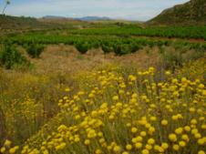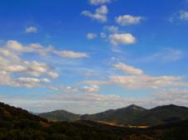

Vineyards: Old vines and new plantings.

Careful control and best-practice policy for viticulture throughout the year
2,500 hectares of vineyards, in a total 4,760 hectares area (14.388 ha D.O. P. Cariñena).

Average yield per hectare: 7.800 kgs.

Highest vineyards in the area, up to an altitude of 850 metres
Cooler evening summer temperatures and high contrasts in temperature
Wines of excellent concentration in colour, sugar, flavour and aroma
Old vines: Traditional bush-vine method, hand-picking.
New plantings: Trellises, mechanisation.

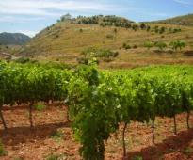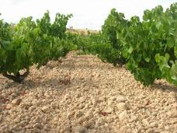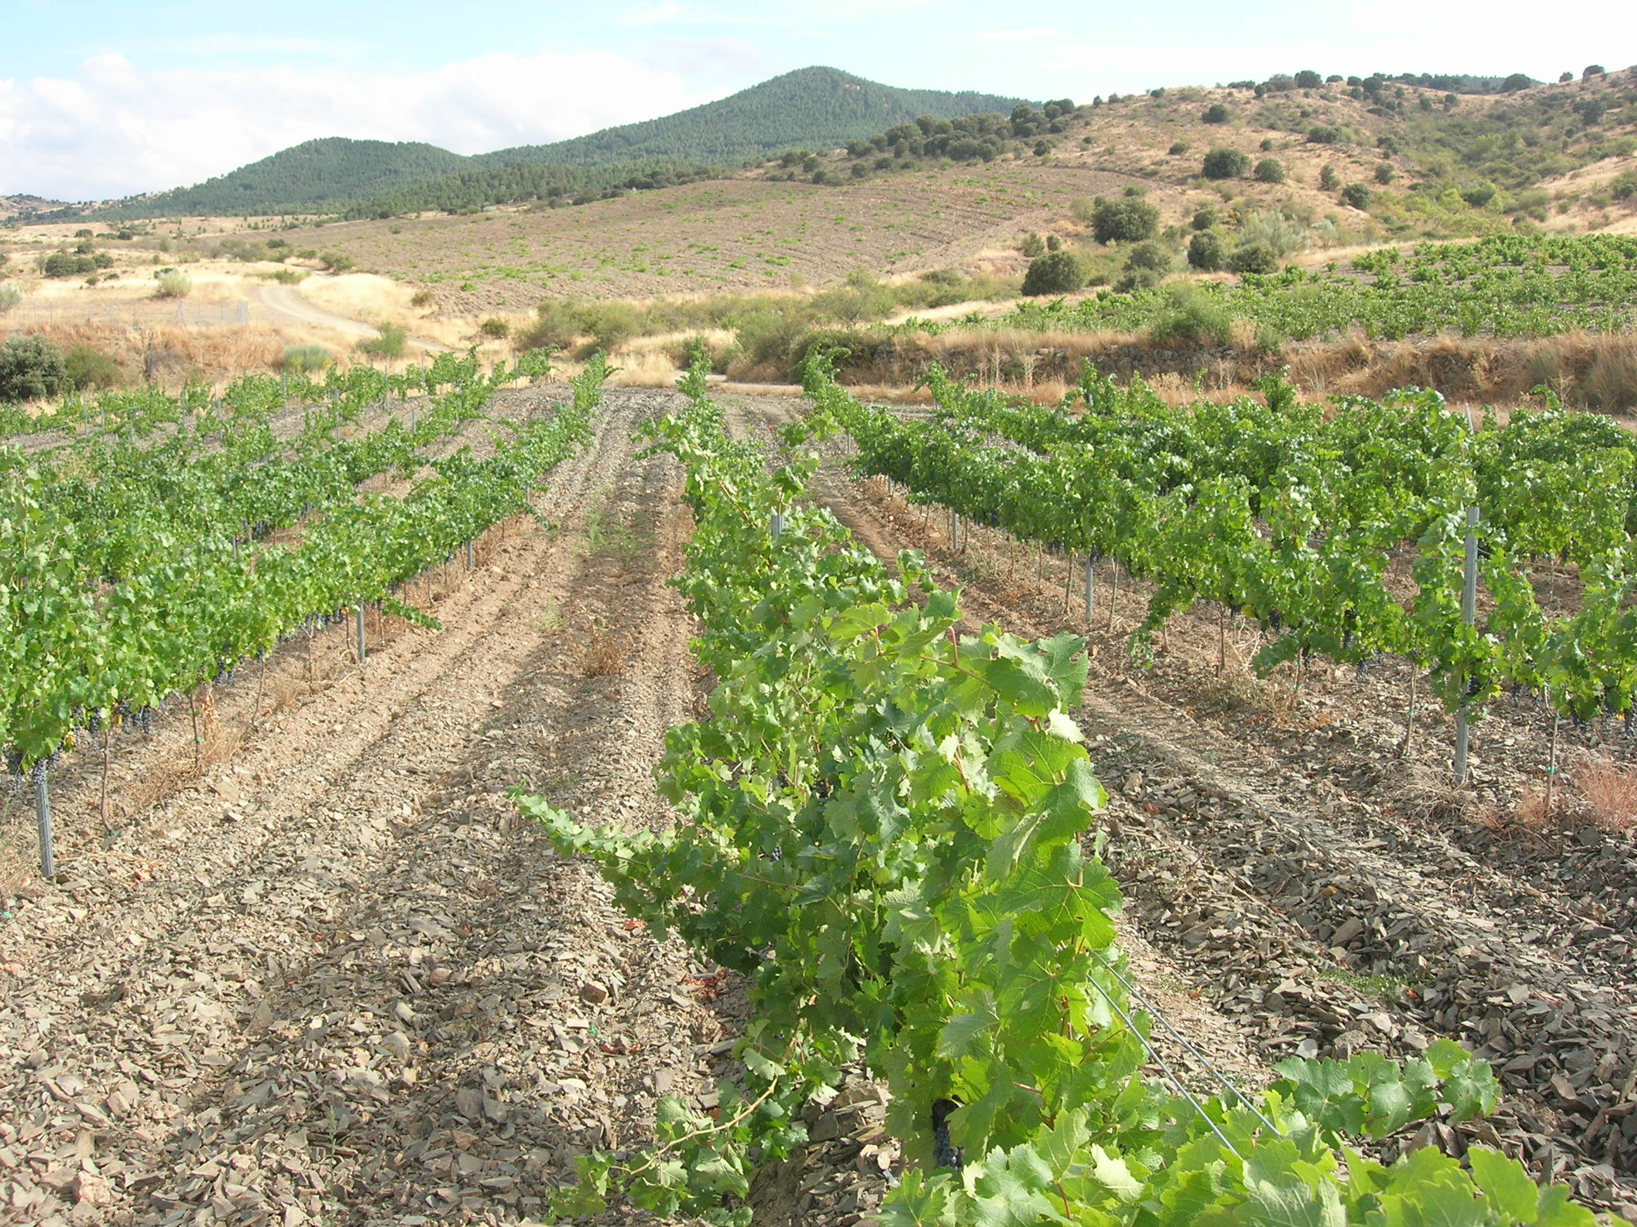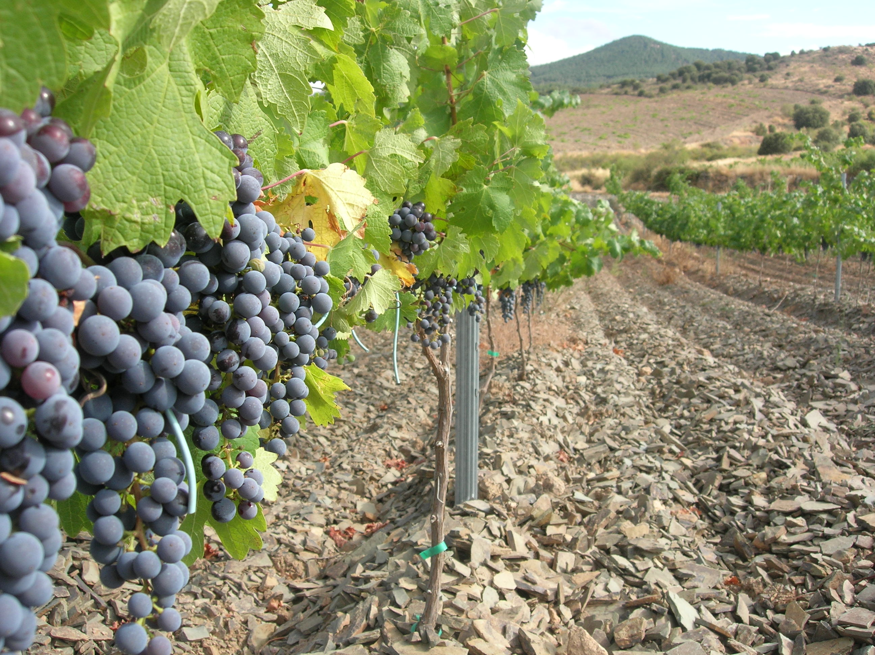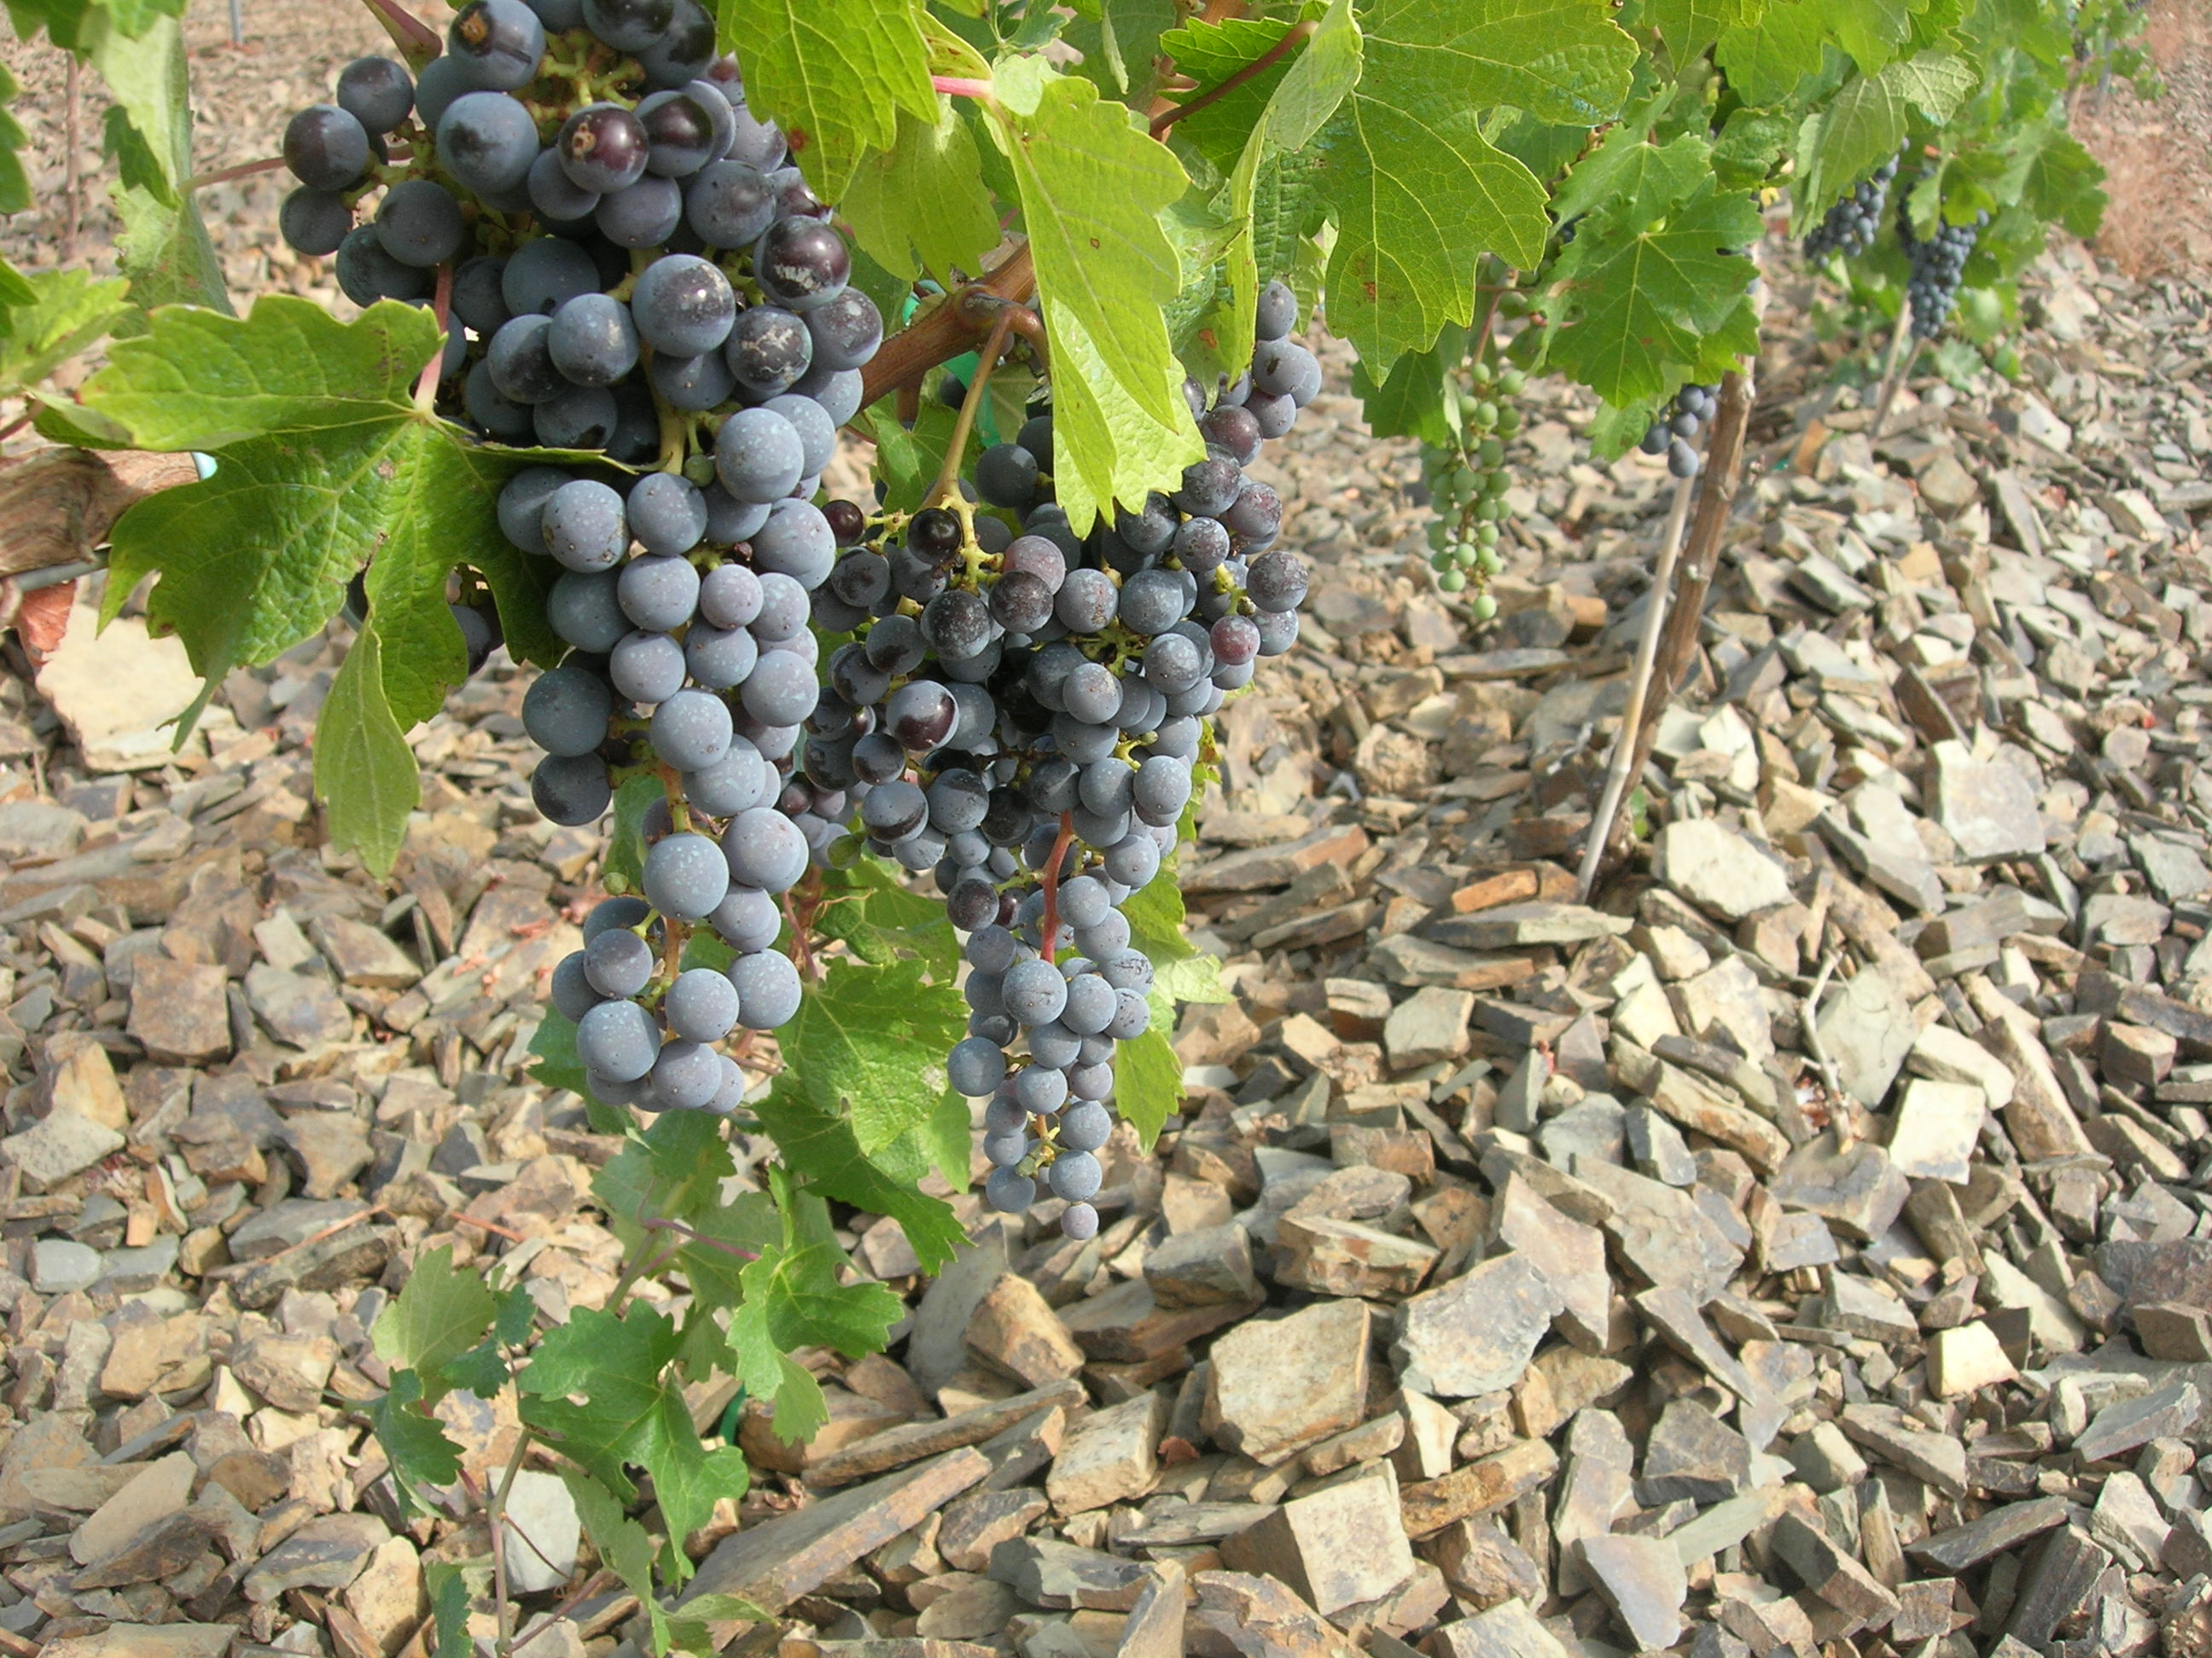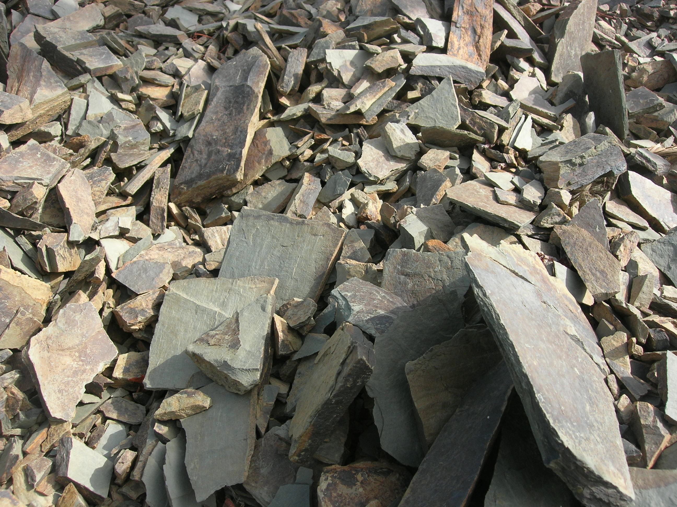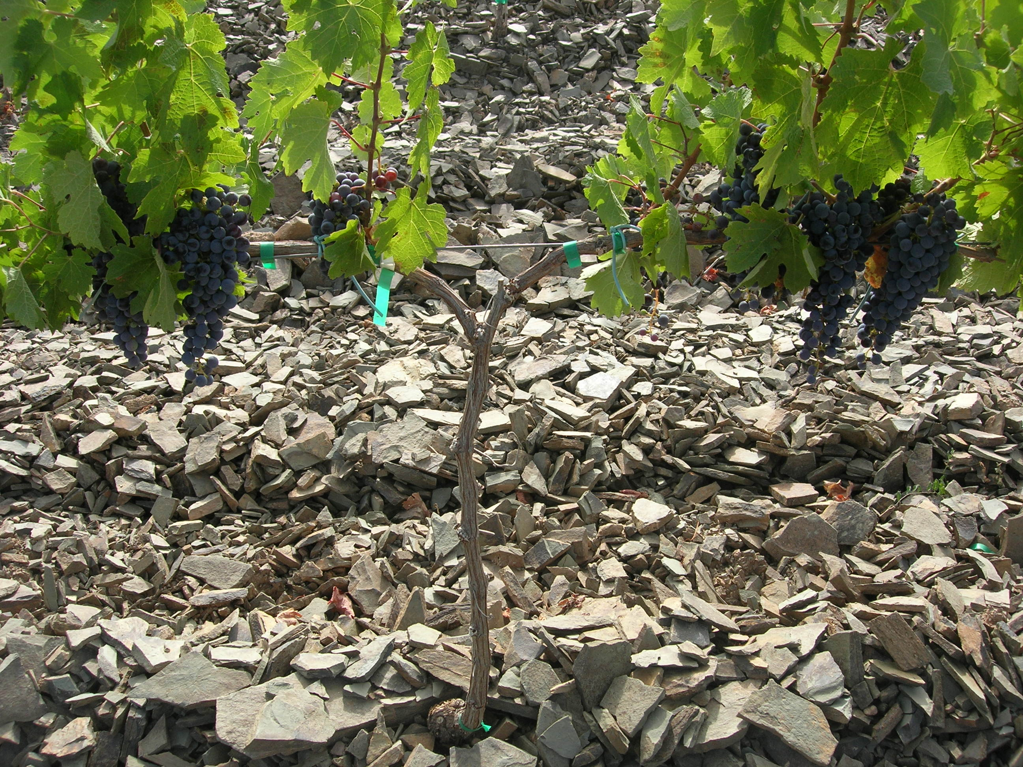

Oldest vines date back to 1906
Main varieties: Tempranillo, Garnacha, Viura (Macabeo)
Very low yields, hand-selected, produce outstanding wines
Development of wines made from 100% old vines
Viable quantities: 76 hectares of vines over 50 years old
Protected for future generations

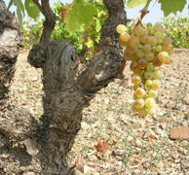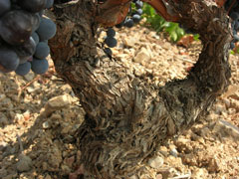

Grape varieties: Local and international.

Grape varieties that are best-suited to our local growing conditions
Native northern Spanish varieties and international classics
Approximately 5.5 million vines (2,500 ha. x 2,166 vines per ha.).

Red Grape Varieties

Tempranillo 24 %
Garnacha (Grenache) 21 %
Cabernet Sauvignon 16 %
Syrah 13 %
Merlot 3 %
Others (Cariñena (Carignan), Moristel (Juan Ibañez)) 3%

White Grape Varieties
Chardonnay 4 %
Viura (Macabeo) 15 %
Parellada 1 %

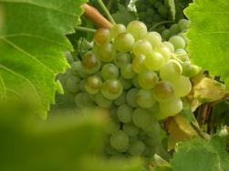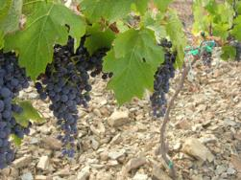

Facilities and capacity

Average of 15 million kilograms of grapes a year.
Storage capacity of 15 million litres in stainless steel vats and oak barrels.
Latest wine-making technology, allowing us to maintain consistently high standards.
Fermentation, stabilization: temperature-controlled conditions (whites: 14-16ºc, reds: 26-28ºc).
15,000 French and American oak barrels.
Underground cellar for bottle-ageing.
Bottling line: capacity of 10,000 bottles per hour.
Efficient logistical service and administration.

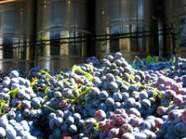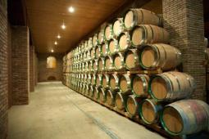

Style of wines

Young, fresh and fruity wines

Soft and easy-drinking wines.
Whites, rosés and reds.
Various styles to suit different market needs. From entry to mid level.
Range of aromas: from crisp floral whites, to red field berries of rosés and rich ripe forest fruit of reds.
Bottled within a year of harvest, to be consumed soon, commercial wines ideal for high volumes.

Oak-aged reds

Classic northern Spanish style.
Main varieties: Tempranillo, Cabernet Sauvignon and Garnacha.
Firm tannins, great ageing potential, complex and interesting.
Aged in 225 litre French and American oak barrels, maturation in bottle.
Crianza (6 + 12), Reserva (12 + 24) and Gran Reserva (24 + 36).
Sophisticated wines, smooth structure, good integration of fruit and oak.

