

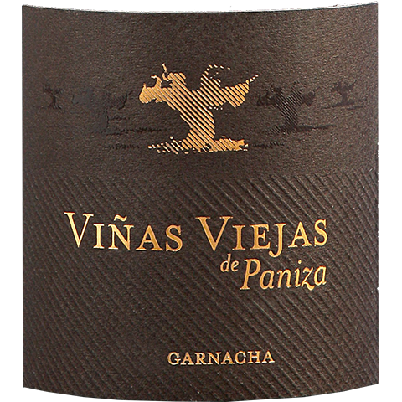

VIÑAS VIEJAS DE PANIZA GARNACHA TINTO
Red wine

Grape Varieties:
100% Garnacha

Vineyards:
2,200 ha at 700 metres altitude with 80 years old average age of vines
Region: D.O.P. Cariñena

Logistical information:
Bottles per case: 6 x 75 cl
Bottle dimensions (mm): 82,7 wide x 297 high
Empty bottle weight (g): 545
Full bottle weight (g): 1245
Case dimensions (mm): 252x168x298
Case weight (kg): 7.99
Cases per palette: 105
Case configuration: 5 layers x 21 cases
Palette dimensions (mm): 1200x800x1700
Loaded palette weight (kg): 865.95

Vinification:
Selected parcels from the variety Grenache, old vines up to 100 years old, coming from the most elevated surroundings of Paniza with slate soils. After crushing and de-stemming, the grape macerates for 15 days and the fermentation takes place afterwards at controlled temperature in stainless steel tanks, with several daily pumping over. After the initial fermentation the wine is drawn off and the malolactic fermentation takes place in oak barrels. Then the wine is decanted and aged in barrels for 6 months.

Certificates: IFS- International Food Standard, BRC- Global Standard Food.

Tasting notes: Colour: Red cherry with violet hints.
Nose: Extremely high intensity, displaying dark fruits such as mulberries, blackberries, cinnamon and hints of dry herbs.
Palate: Long, structured, persistent and tasty with long wild black fruit and mineral notes.
Recommended with: Ideal with roast meat, cooked tomatoes, toasted bread.
fruity finish. Serve at 12-15 ºC (54-59 ºF).

Climate: Continental climate with very hot summers and very cold winters, and a sharp contrast in temperature between night and day. Annual precipitation is low (360 mm), while insolation is high (2,800 hours). These factors favour intense and complex wines, full of character.

Terroir: Hilly terrain at base of the Iberian Mountains. Soils composed of schist, chalk, loams and red clays.

Winery: Our winery receives an average of 12 million kilograms of grapes a year and has a storage capacity of 11 million litres. Equipped with the latest wine-making technology, fermentation and stabilization take place under temperature-controlled conditions. Storage and ageing are allocated according to type of wine: young whites, rosés and reds in stainless steel; Crianzas, Reservas and Gran Reservas in our cool dark cellars, where there are 13,000 French and American oak barrels and an area for bottle-ageing. Our bottling line has a capacity of 8,000 bottles per hour.

