This is Rioja’s ‘first’ official single vineyard wine

The Drinks Business Logo

9th October, 2019 by Edith Hancock

A Spanish winery has produced what it believes to be the country’s first official single vineyard Rioja, following a shake-up of labelling rules in the region.

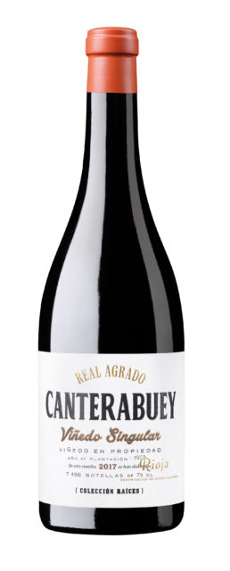

Called Canterabuey, it is the first Rioja wine to gain a Viñedo Singular certification, according to producer Viñedos de Alfro, an estate founded in 1974. The wine is made from 100% Garnacha grapes, from a plot of 3.5 hectares planted in 1975 and located in “a very dry area with poor, alluvial soils”, according to the estate.

The wine is aged for 16 months in French and American oak barrels. Total production for this first vintage is 7,496 bottles.

There have been a number of changes to the classification system used in Rioja in the past two years, including a completely new category; Viñedos Singulares.

Designed to highlight the terroir and origins of the wine, as well as reflect the diversity of the region, [it was introduced in June 2017](https://www.thedrinksbusiness.com/2018/04/everything-you-need-to-know-about-riojas-new-rules/2/).

The wines have to come from a single vineyard with differentiating characteristics versus other vineyards in the neighbourhood. The vines must also be 35 years old, and “treated with care following sustainable policies”, while the grapes must be hand-harvested.

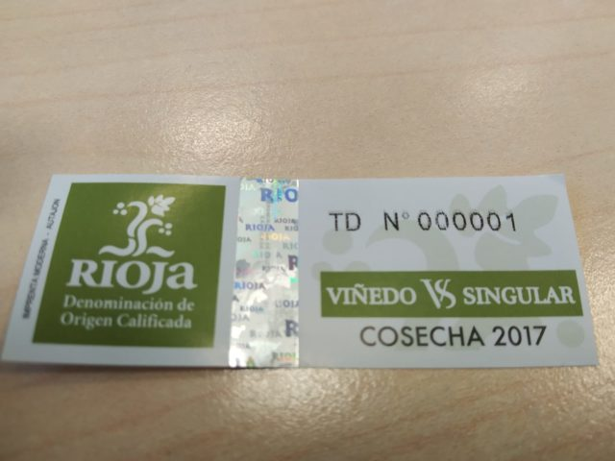

In July 2019 the first list of Viñedos Singulares was revealed, but before they are released to market, the wine must be given approval by a special tasting panel set by the Rioja Board.

Viñedos de Alfaro, located in Rioja Oriental, comprises of around 100 hectares of vineyards. The estate was recently acquired by El Gaitero, a family-run cider business.

Canterabuey is one of four wines in a premium range produced by Real Agrado, Viñedos de Alfro’s wine brand, called Colección Raices. “We include only the limited production wines,” a spokesperson said, “with distinctive personality and coming exclusively from a single plot or vineyard that gives the name to the wine.”

[Share133](https://www.facebook.com/share.php?u=https%3A%2F%2Fwww.thedrinksbusiness.com%2F2019%2F10%2Fspanish-estate-launches-riojas-first-certified-single-vineyard-wine%2F)

[Tweet](https://twitter.com/intent/tweet?text=This+is+Rioja%27s+%27first%27+official+single+vineyard+wine&url=https%3A%2F%2Fwww.thedrinksbusiness.com%2F2019%2F10%2Fspanish-estate-launches-riojas-first-certified-single-vineyard-wine%2F&via=teamdb)

Pin2