Pink Elephant Social Media Posts

Post 1:
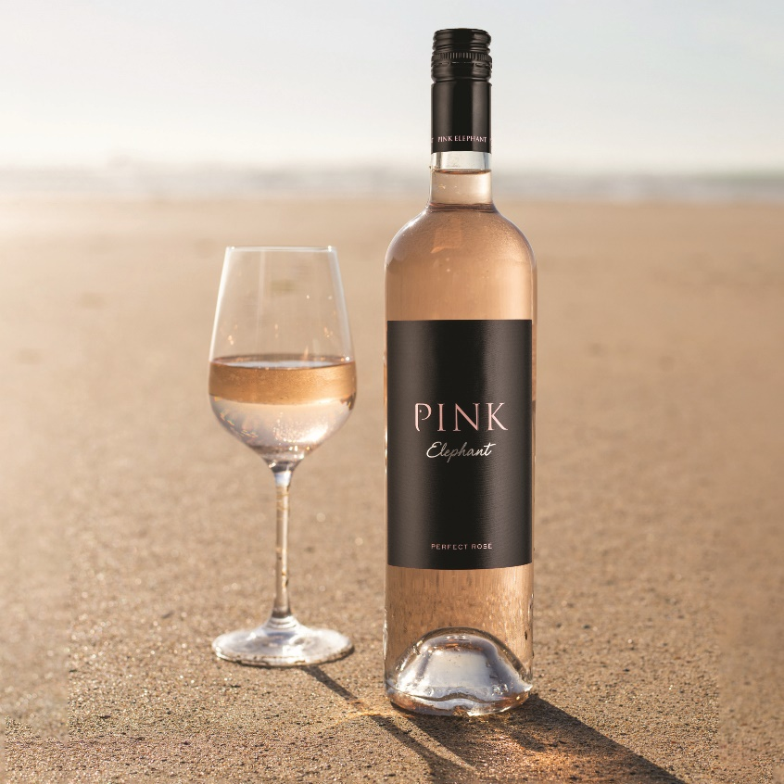
Pink Elephant is not only a delicious rosé, it’s also a wine with a conscience 🍷 For every bottle sold, a donation is made to @elephantfamily, a charity dedicated to protecting Asian Elephants and their habitats 🐘
#PinkElephantWine #ElephantFamily #Charity #ElephantConservation #AsianElephants #RoséWine #SpanishWine

Post 2:
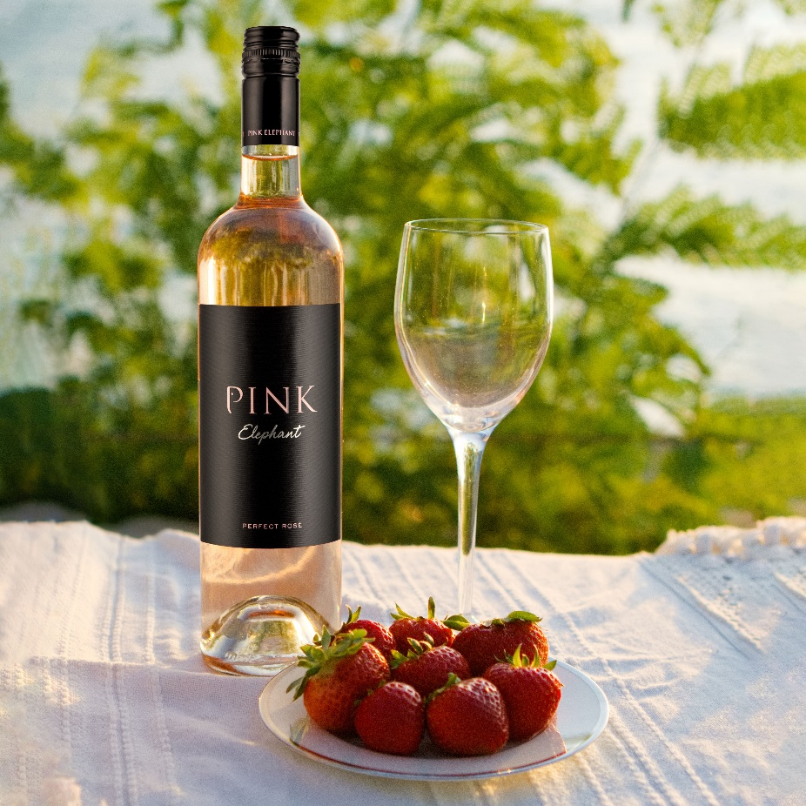
Light, refreshing and full of flavour 🌸, only the best Garnacha grapes are selected for Pink Elephant 🍇 Hailing from the Navarra region in Northern Spain 🇪🇸, this stunning rosé is the perfect summer wine, boasting juicy flavours of strawberries and raspberries – like summer in a glass 🌞 🍷
#PinkElephantWine #ElephantFamily #Charity #ElephantConservation #AsianElephants #RoséWine #SpanishWine

Post 3:
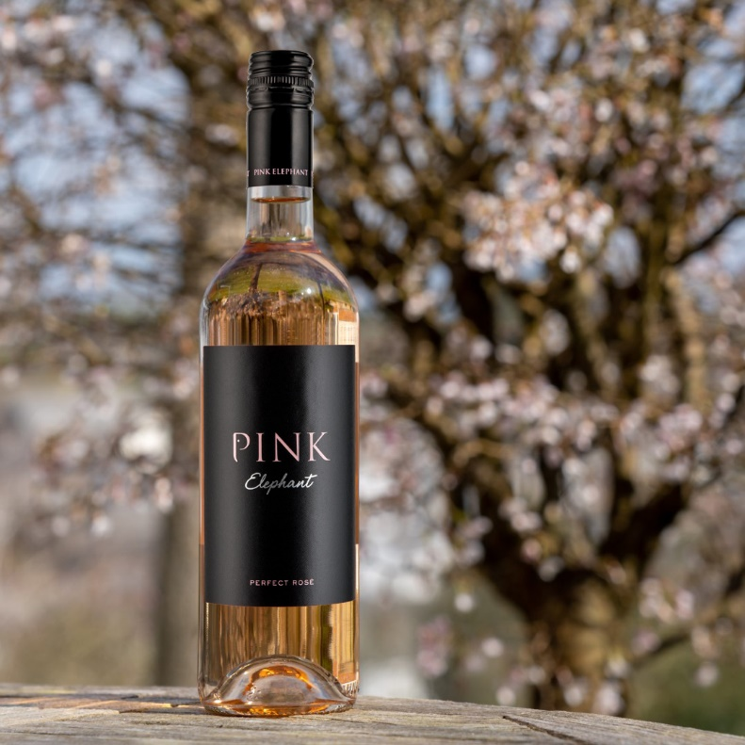
Did you know, our Pink Elephant rosé is the perfect companion to Asian cuisine? 😍🍛Its light, juicy summer fruit flavours pair beautifully with Pad Thai, Indian curries and seafood dishes. What will you be pairing this refreshing rosé with? 🍽️
#PinkElephantWine #ElephantFamily #Charity #ElephantConservation #AsianElephants #RoséWine #SpanishWine #FoodAndWine #WinePairings

